# **Website - Staging view:**

## [**https://www.blu-baar.ch/?prv=07_2024**](https://www.blu-baar.ch/?prv=07_2024)

# **PDF files:**

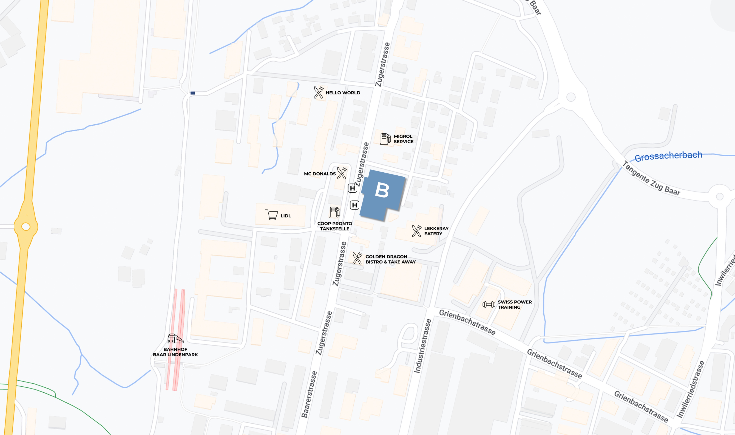

## **Urban infrastructure (micro-location highlights) around Zugerstrasse 57, Baar**

**Gastronomy**:

* *Ristorante Pizzeria Maddalena* (150 m) – Italian cuisine
* *Thai Cuisine Benjarong* (150 yards) – Thai-Gerichte
* *McDonald's* (300 m)

**Business and services**:

* *Butcher's shop Zumbach* (600 m)
* *Post Baar* (550 m)

**Leisure & Fitness**:

* *Fitnesspark Zug* (1.2 km)

**Health care**:

* *General Practitioner Centre Baar* (800 m)
* *Zahnarzt Dr. Schmid* (600 m)
* *Apotheke Baar* (550 m)

**Hotels & Conferences**:

* *ibis Baar Zug* (550 m)
* *Visibility* : 2 km

**Daycare centres**:

* *Island4Kids* (Weststrasse 3, 900 m)
* *Kita Zwergenburg* (Huebweid 1.1 km)
* *Kidscare Baar* (Zugerstrasse 50, 300 m)

**Supermarkets & Shopping**:

* *Coop Pronto* (Zugerstrasse 64, 200 m)
* *Lidl* (Sagistrasse 10, 500 m)

## **Direct neighbours**

**1. Legal and business consulting**

* **Zulauf Asset Management AG:** Asset management.
* **Accuro AG:** International management consulting and asset management.
* **Aran Asset Management SA:** Asset management and financial advice.

**2. Less important companies and industries**

* **IT and technology companies**: Smaller IT support and technical consulting service providers.
* **Garages and car repair shops**: There are several car repair shops and smaller service companies for vehicles
* **Plumbing and construction**: Plumbing and construction installation companies are also represented in this region

## **Historical aspects:**

The history of the property at **Zugerstrasse 57 in Baar** has changed considerably over the last 100 years.

**10 years ago:**

By 2014, Zugerstrasse 57 was already a location for major international companies such as **Partners Group**, a global investment firm active in the private markets sector. At that time, it offered services in the field of asset management and financial advice

**50 years ago:**

In the 1970s, Baar was known as a business location above all due to its rapid development. During this time, the region began its transformation into an important financial and industrial hub. Large companies such as **Lego** also had production facilities here

**100 years ago:**

Around 1920, the area around Baar was still strongly agricultural. Zugerstrasse, including number 57, was part of a rural village that stretched mainly along the road between **Lake Zug** and **Lake Zurich** . The region only began to experience greater industrialization and commercialization after the Second World War

## **Why is Blu-Baar called that?**

"Blu" is a phonetic allusion to the word "blue" and refers to the tinted glass façade of the property, which reflects in a characteristic shade of blue. This concise terminology symbolises the striking blue reflection of the façade. On the one hand, the term "Baar" refers to the location of the building, and on the other hand, "bar" can also be understood as "bar" in English. This results in the image of a "blue bar" – a perfect combination of location and design.

The brand of the **Blu-Baar** commercial property is based on a clear, modern and effective property identity. Here is a detailed explanation of the brand philosophy:

**1. Naming and meaning**

* **"Blu"** refers to the building's striking, blue reflective glass façade. This façade gives the property a modern and self-confident appearance. The reflection of the façade is emblematic of the clarity and innovative character of the building.
* **"Baar"** specifies the location and anchors the building locally in the Zug/Baar region. This regional location is important in order to establish a close connection to the micro-location.

**2. International and language-neutral conciseness**

The name "Blu-Baar" is deliberately short, memorable and easy to pronounce. It works in a language-neutral manner in various international contexts, which gives the brand a universal character and also makes it easy to understand on a global level.

**3. Memorability and recognition**

* Due to its brevity and distinctive sound, "Blu-Baar" is easily noticeable. This contributes to a high level of recognition, both for potential tenants and business partners.
* The name is flexible and can be applied in different usage scenarios, for example as **Blu Gastro**, **Blu Business** or **Blu Education**, depending on the future use of the property.

**4. Visual identity**

* The logo is a sans serif typeface mark that focuses on simplicity and room for ideas. It is easy to use both physically and digitally.
* The **spacing** of the logo symbolizes room for ideas, while the clean lines of the sans serif font signal high flexibility and efficiency. The reduced "R" in the logo stands for a clear, efficient focus.

**5. Strong building identity**

* The **Blu-Baar** brand aims to be not just a temporary marketing brand, but to create a long-term identity for the building. The brand is intended to give the building a strong identifying feature in the Zug/Baar area that has a lasting effect.

The "Blu-Baar" brand thus combines modern design, local roots and international comprehensibility, giving the property a strong, recognizable identity that goes beyond mere marketing

## **Project description (cst, 24.9.24 patchwork various sources):**

1. **Description**

The modern office space in Baar, in the canton of Zug, offers companies a first-class location in the Zurich metropolitan region. Geographically, Baar is located between Lake Zug and the hills of the Zugerberg, embedded in an economically dynamic region with a high quality of life. The community itself is characterized by a cosmopolitan and tolerant population that offers a pleasant environment for employees and companies.

Baar has excellent transport connections:

The trains from **Baar Neufeld** to **Zürich Hauptbahnhof** run with an approximate frequency of 10 to 15 minutes, depending on the time of day and the line. The connection to **Lucerne** runs via the IR70 line, which departs every 30 minutes. Trains to Zurich run at minute 10 and to Lucerne at minute 9.

* **Zurich**: approx. 25 km away, 30 minutes by car or 40 minutes by train
* **Train**: about 10 km away, 15 minutes by car or 10 minutes by train
* **Lucerne**: approx. 35 km away, 40 minutes by car or 50 minutes by train

This central location allows companies and employees to commute quickly and efficiently, which further increases the attractiveness of the location. Zug is a leading economic center in Switzerland, characterized by low corporate taxes and business-friendly policies. This has attracted numerous international companies, especially from the financial services, technology and pharmaceutical sectors. The economic environment promotes innovation and contributes to stability and growth in the region.

1. **Space supply**

The available office space comprises a generous total area of **8,946 m²**, which will be available as a single-tenant property from the beginning of 2026. The area layout is as follows:

* **Ground floor**: 2,247 m²
* **1st floor**: 2,028 m²
* **2nd floor**: 2,076 m²
* **3rd floor**: 1,105 m²
* **Size**: 1'490 m²

The spaces are fully customizable and offer companies the opportunity to develop tailor-made room concepts. Whether team rooms, meeting rooms, creative areas or retreat zones for concentrated work – the offices can be flexibly adapted to the specific needs of the tenants. Modern working concepts such as open-space structures or desk-sharing models can also be implemented without any problems.

The **desk share ratio** is a land use principle that is also becoming established in Switzerland in the wake of the increasing spread of remote work models. This makes it possible to use office space efficiently by defining a ratio of workplaces to employees. A ratio of 1:1.5 or 1:2 is often aimed for in order to promote the use of common areas and reduce the need for fixed workplaces.

The space on offer also offers the opportunity to implement contemporary forms of work based on the principle of **New Work** . **New Work** does not describe a fixed structure, but inspires companies to optimize their office concepts in such a way that they support modern, flexible ways of working such as remote work and agile methods. The room layout can be adapted to individual requirements in order to offer employees an optimal working environment.

1. **Highlights**

The office space in Baar not only offers flexibility in design, but also a variety of amenities that can be of great importance for potential tenants and their employees. Aspects such as health promotion and sustainable workplace design are an important part of many companies' corporate culture and make a significant contribution to the well-being of their employees.

A sports room with showers and cloakrooms, for example, offers the opportunity to integrate sporting activities into everyday working life. A separate canteen on the 4th floor provides fresh, healthy and sustainable catering options. Providing vegetarian, vegan and allergy-friendly meals can support employees in their diet and promote productivity. The use of regional and seasonal ingredients shows the commitment to sustainable and responsible supply, which is important both ecologically and socially.

The design of the working environment and additional offers such as quiet zones or retreat rooms are important factors that companies should consider in order to ensure the well-being of their employees in the long term. These aspects are a central element of modern workplace concepts and offer companies the opportunity to create a healthy and productive environment that meets the current needs of the workplace.

1. **Equipment**

The Blu-Baar's equipment and additional services support modern work concepts such as **New Work** and offer a variety of amenities that promote the well-being of employees. Key highlights include:

* **Sunny, spacious terrace**: ideal for breaks and outdoor relaxation.
* **Canteen / café on the 2nd floor**: Fresh, healthy and sustainable catering options, including vegetarian and vegan options.
* **Fitness/Sports/Dance Room**: Equipped with natural light, showers and cloakrooms to integrate sports activities into everyday work.
* **110 parking spaces and 30 outdoor parking spaces**: For employees and visitors.
* **Flexible room design**: Possibility to implement individual office layouts and open-space structures.

1. **Tax advantages and location attractiveness**

Compared to Zurich, Baar offers significant tax advantages with a corporate tax rate of around **13.0%.** This is significantly cheaper than in Zurich, where the rate is around 21.0%, resulting in significant financial benefits for companies setting up in the region.

Baar combines economic strength with a high quality of life, which makes the location particularly attractive for international companies. The proximity to important economic centers as well as the availability of recreational and leisure opportunities such as Lake Zug and the Zugerberg contribute to the fact that employees can enjoy an excellent work-life balance.

1. **Contact**

Olivia Feller, Letting Advisory at Swiss Prime Site Immobilien, will be happy to **provide you with detailed information and individual advice**. It not only offers you comprehensive advice, but also supports you in the development of tailor-made solutions, including the preparation of layout studies, in order to make the most of the potential of the office space.

Contact:

**Olivia Feller**

Letting Advisory

T: +41 58 317 16 67

E-Mail: [olivia.feller@sps.swiss](mailto:olivia.feller@sps.swiss)

Do not hesitate to make an appointment for a viewing. We look forward to realizing your new office space together with you.

## Potential Inputs from Users

|  |  |
| --- | --- |
| **Possible questions** | **Possible answers** |
| What office space is currently available? | For current availability, please refer to the rental overview on our website or contact our rental team. |
| How big are the individual office units? | The office space varies in size and ranges from smaller units from 100 m² to large-scale solutions over 1,000 m². |
| What are the rents per square metre? | The prices depend on the size and equipment of the areas. For detailed information, please contact us. |
| What is the possible rental period? | Leases can be designed flexibly, with terms starting at one year. |
| Are flexible leases available? | Yes, we offer flexible contract models that are tailored to your individual needs. |
| What services are included in the rent? | The rental prices include services such as building maintenance, cleaning and security services. |
| Is there a minimum rental period? | The minimum rental period is usually 12 months, but can be adjusted depending on the office space. |
| Are the rooms furnished or unfurnished? | Our offices are rented unfurnished, but offer the possibility to equip them according to your wishes. |
| Are there parking facilities for tenants? | Yes, there are plenty of parking spaces available for tenants. |
| What is the connection to public transport? | The building is well connected to public transport, with bus stops and train stations in the immediate vicinity. |
| Are the offices barrier-free? | Yes, all office space is barrier-free. |
| What technical facilities are available? | The building is equipped with state-of-the-art infrastructure such as fiber optic internet, conference rooms, and smart building technologies. |
| Are additional services such as cleaning available? | Yes, office cleaning services can be provided upon request. |
| Are there safety precautions in the building? | The building is equipped with a comprehensive security concept, including access controls and video surveillance. |
| What common areas are available? | The tenants have conference rooms, break areas and a roof terrace at their disposal for common use. |
| Can I see the floor plan of the office space? | Floor plans are available on the website or can be sent on request. |
| Is there a way to visit the office space? | Yes, we offer personal viewing appointments. Please contact us for an appointment. |
| How many offices are there in total at BluBaar? | The BluBaar has a total of 50 modern office units. |
| Is there a canteen or other catering options? | There is a bistro for snacks and lunch in the building, as well as various restaurants nearby. |
| What is the energy concept of the building? | The BluBaar was built according to modern, energy-efficient standards and uses sustainable energy concepts, such as heat recovery. |
| Are there sustainable construction or energy technologies? | Yes, the building uses sustainable technologies such as photovoltaic systems and energy-efficient heating and cooling systems. |
| Who is the landlord or contact person? | You can find the contact information of the rental team on our website or you can use the chatbot for a direct connection. |
| How can I reserve or rent an office? | To reserve an office, please contact our rental team or use our online contact form. |
| Are there any current promotions or discounts? | You can find information about current promotions on our website or you can contact us directly. |
| What is the maximum number of people that fit in an office unit? | Depending on the size of the office unit, they can accommodate between 5 and 100 people. |
| What are the terms of the contract? | The terms of the contract depend on the rental period and the size of the space and can be customized individually. |
| Are there coworking opportunities? | Yes, we also offer flexible coworking offices for start-ups and smaller teams. |
| What is the room layout in the offices? | The room layout can be flexibly designed and adapted to your specific requirements. |
| Are there expansion options for larger areas? | Yes, additional office space can be booked subject to availability. |
| What facilities do the conference rooms offer? | Our conference rooms are equipped with state-of-the-art presentation technology and can accommodate up to 50 people. |
| Is there a reception service in the building? | Yes, a reception and postal service is available to all tenants. |
| Can I rent office space at short notice? | Short-term rental contracts are possible, depending on availability and duration of use. |
| How high are the ancillary costs? | Ancillary costs vary depending on the size of the office and use and include costs for heating, water and electricity. |
| Do you offer office space with a view? | Yes, some of our offices offer impressive views of the surrounding region and the city. |
| Is there an underground car park for tenants? | Yes, there is an underground car park with sufficient parking spaces available for tenants. |
| How is the office climate regulated? | The office climate is regulated by modern heating and air conditioning systems as well as a ventilation system. |
| Can I get special conditions as a start-up? | For start-ups, we offer flexible rental models and discounted conditions. |
| Are there shopping facilities in the area? | Yes, you will find various shopping facilities and services in the immediate vicinity. |
| How long does the rental process take? | The rental process can take anywhere from a few days to several weeks, depending on availability and contract negotiations. |
| Are there bicycle parking spaces in the building? | Yes, there are secure bicycle parking spaces for tenants. |
| Is there a fee for the use of common areas? | Some common areas are free to use, while others, such as conference rooms, can be booked as needed. |
| What payment methods do you offer? | The rent payments are made monthly by bank transfer. Other payment options are also possible on request. |
| Is there technical support on site? | Yes, technical support is available on demand and can be requested through our facility management. |
| What is the accessibility outside of business hours? | All tenants have round-the-clock access to their offices via secure access control. |
| Are the offices soundproofed? | Yes, the offices have modern soundproofing measures to ensure a quiet working environment. |
| Can I customize my office space? | Yes, within certain framework conditions, you can design the office space according to your wishes. |
| What are the additional costs? | In addition to the rental costs, there are additional costs such as electricity, heating and water, and there may be additional costs for optional services such as cleaning and conference rooms. |
| Is a deposit required? | Yes, as a rule, a rental deposit of three months' rent is required. |

## Default Replies

"Interesting! Unfortunately, your question has nothing to do with Blu-Baar's office space. But who knows, maybe there is an office hiding somewhere in your question, and I just overlooked it!"

"Oh, I digress! When it comes to Blu-Baar, I'm the absolute expert. I prefer to leave everything else to the people."

"It sounds exciting, but I'm not the right person to talk to about this topic. Let's get back to the inspiring offices of Blu-Baar!"

"Interesting thought! But my specialty is in the world of Blu-Baar. I would be happy if I can help you with this."

"Ah, I understand the enthusiasm! For information outside the Blu-Baar world, I recommend talking to someone who is just as enthusiastic."

"A fascinating question! However, my focus is entirely on Blu-Baar's modern workspaces. I'm happy to help!"

"That sounds exciting! However, I am well programmed for questions about Blu-Baar. Ask me anything about our office space!"

"I love how creative your question is! Unfortunately, it does not fall within my sphere of knowledge. But I'm an expert on everything that concerns Blu-Baar."

"Hmm, that's a topic that's outside my repertoire. How about we talk about Blu-Baar's flexible offices instead?"